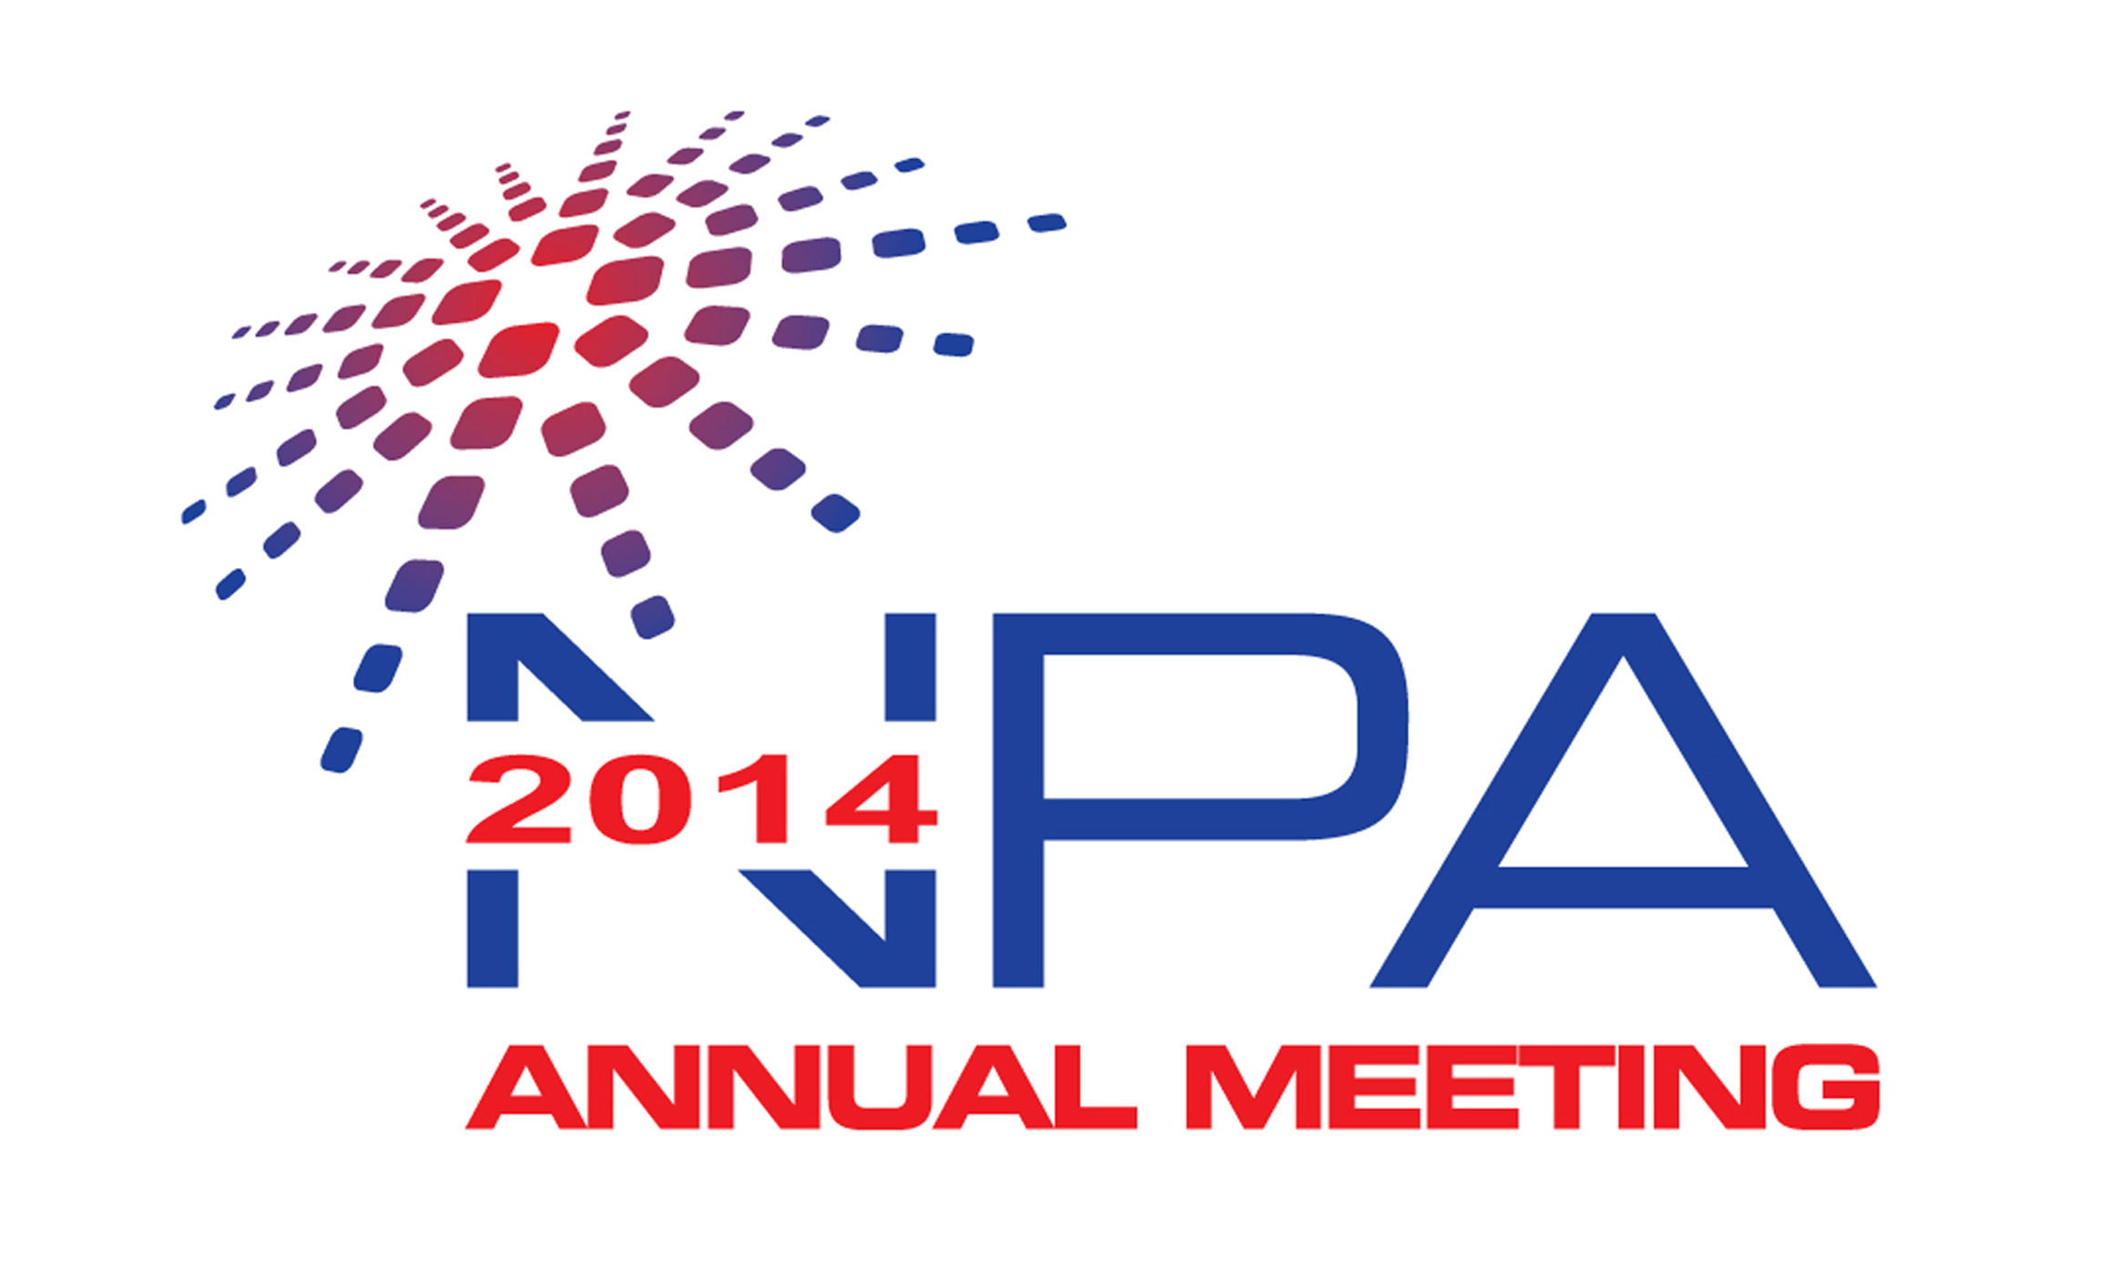
Diversifying Your Career Path
Advice for Transferring Your Skills Outside of Academia

Career paths for doctoral students and postdoctoral researchers have historically focused on securing tenure track faculty positions. With 40,000 to almost 90,000 postdocs in the workforce, these coveted positions are becoming increasingly scarce. In addition to the economic realities of academic science, there is a growing trend towards raising awareness of opportunities for PhD-level professionals in such areas as communications, policy, entrepreneurship, consulting and program management. As a result, postdocs progressively are encouraged to expand the scope of their career planning beyond traditional research and academic positions.

Core Learning Objectives:

- Attendees will learn how to identify transferrable skills, examine career options and how to pursue various career paths.
- Panel members will provide advice on handling the "culture shock" of going from the bench to the boardroom--i.e. am I still a scientist?
- The attendees will learn how to frame unique skills when networking and applying for diverse jobs.

Workshop Participants:

- Kathleen Carrado Gregar, Ph.D., Manager, User & Outreach Programs at Argonne National Laboratory Center for Nanoscale Materials
- Kenneth Gibbs, Jr, Ph.D., Cancer Prevention Fellow at the National Cancer Institute
- Andrew R. Hilgenbrink, Ph.D., Director at Cummings Bay Capital Management, L.P.
- Jeffrey Margolis, Ph.D., Managing Director, Illinois Science & Technology Coalition

Workshop Moderator and Point of Contact: Kristene "Tina" Henne, Ph.D., Postdoctoral Program Coordinator, Communication, Education and Public Affairs, Argonne National Laboratory; khenne@anl.gov

Recommended Resources

NPA Core Competencies: As the research landscape continues to evolve, new opportunities and career paths for postdoctoral scholars to apply their knowledge and skills outside of academia arise. The NPA Core Competencies captures 6 major needs for postdocs to segue into professional careers. The document provides ideas and resources on how you can help your postdocs master these skills: http://www.nationalpostdoc.org/competencies

Literature:
- Gibbs, Jr., Kenneth D. and Griffin, Kimberly A. What Do I Want to Be with My PhD? The Roles of Personal Values and Structural Dynamics in Shaping the Career Interests of Recent Biomedical Science PhD Graduates. CBE Life Sci Educ December 2, 2013 12:711-723. Retrieved from: http://www.lifescied.org/content/12/4/711.full
- OECD (2012), Transferable Skills Training for Researchers: Supporting Career Development and Research, OECD Publishing. Available for download at: http://www.oecd.org/science/transferableskills.htm
- Robbins-Roth, Cynthia (ed.) (2006), Alternative Careers in Science: Leaving the Ivory Tower, 2nd Edition. Elsevier Academic Press.
- Sauermann H, Roach M (2012) Science PhD Career Preferences: Levels, Changes, and Advisor Encouragement. PLoS ONE 7(5): e36307. doi: 10.1371/journal.pone.0036307

Websites and LinkedIn Groups:
- Versatile PhD: http://versatilephd.com/ Provides resources and an overview of diverse careers for PhDs in STEM, the Humanities and Social Sciences. Also provides opportunities for networking with individuals in your local community.
- SciPhD: www.sciphd.com Resources, consulting service, webinars, online assessment tools and guidance professional career preparation for PhDs.
- Vitae: www.vitae.ac.uk Tailored for researchers, this site offers a professional development framework and support tools for career skills development.
- PhD Careers Outside of Academia: LinkedIn group for PhDs considering non-academic careers. Allows for networking, discussion and job seeking to members.
- Science Careers: http://sciencecareers.sciencemag.org/ AAAS Science Careers publishes career profiles, perspectives and advice articles on a variety of careers. Also hosts the myIDP tool that enables career skills assessment and development plan.
- Next Scientist: http://www.nextscientist.com/ Tips and tools for PhD Career success, including articles such as “11 Alternative Careers for PhD Students”.

Academic Career Development Programs:
University career preparation programs have begun developing resources for graduate students and postdocs that provide guidance for those seeking diverse career paths. Some examples may be found at:

- Stanford University Career Development Center: http://studentaffairs.stanford.edu/cdc/phd/resources-outside-academia
- University of California-San Diego Careers Beyond Academia Handbook: https://career.ucsd.edu/_files/Beyond%20Academia%20Job%20Search%20Handbook.pdf
- Cornell University Career Services for Graduate Students: http://www.career.cornell.edu/students/grad/index.cfm

